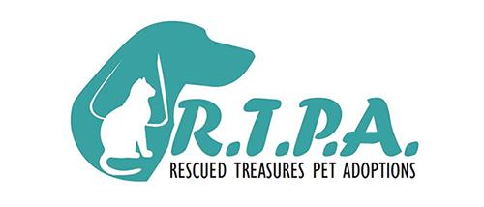
Deposit agreement
By signing this DEPOSIT CONTRACT, I understand that Rescued Treasures Pet Adoptions is holding a cat/kitten for me, to be adopted when it is deemed ready to adopt. Before my animal becomes available, I will be called on the phone number(s) I have provided or communicated via e-mail/Facebook, and a message will be left if there is no answer.
At that time that my pet is ready for adoption, I will have three days to call back with a time and place for pick up and adopt, unless previous arrangements have been agreed upon. If I do not contact Rescued Treasures Pet Adoptions within three days of the adoption date, my deposit will be forfeited, and the animal will be placed up for adoption to the next person on the list. I understand that my deposit is non-refundable. If I do adopt the animal, the deposit will be applied to my adoption fee at the time of adoption. If at any point while the animal is on hold for me and I decide I no longer want to adopt him/her, I will contact Rescued Treasures Pet Adoptions as soon as possible, and my deposit will be considered a donation to the shelter.
Name (Print) __________________________________________________________________________
Signature ______________________________________________________________________
Witness ______________________________________________________________________
Date _____________
Animal’s Name _________________________________________________________________
Color __________________ Sex ____
Home Phone # ____________________________ Cell Phone # __________________________
Email ___________________________________ Deposit Amount $______________________

